Project Report Template

## 1 INTRODUCTION:

### Overview:

Analytics the performance & efficiency of the Radisson hotels using data visualisation techniques

### Purpose:

It helps you to connect with several data sources, analyze data, and visualize it to get superior insights.

## Problem Definition & Design Thinking:

### Empathy Map:

### Ideation & Brainstorming Map:

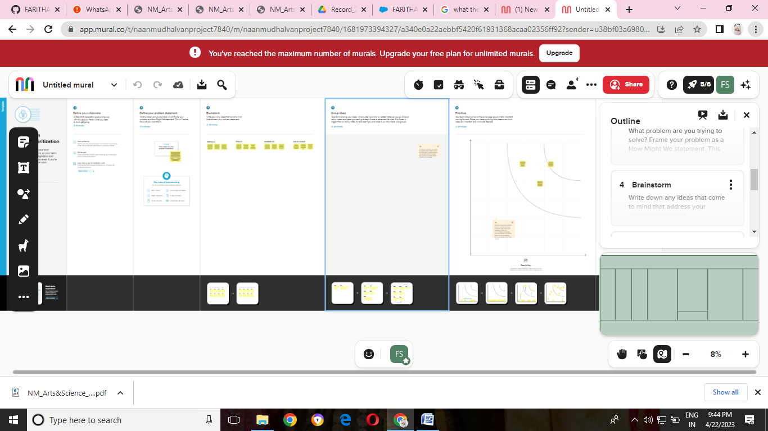

### RESULT:

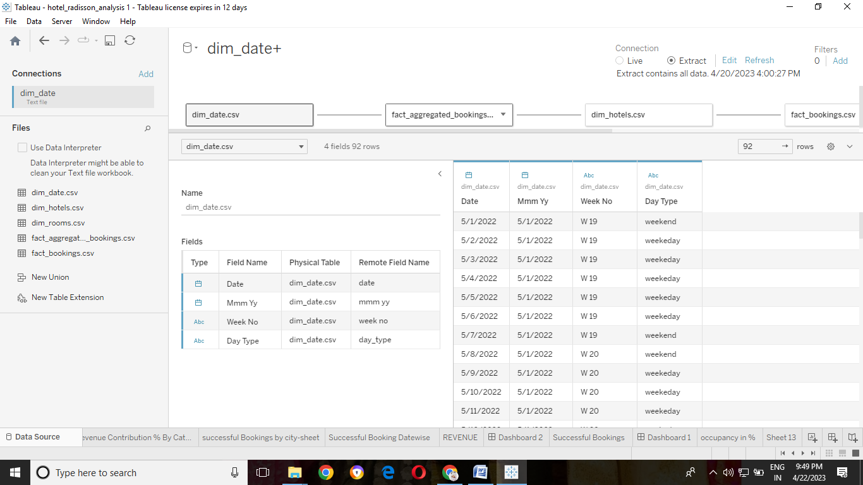

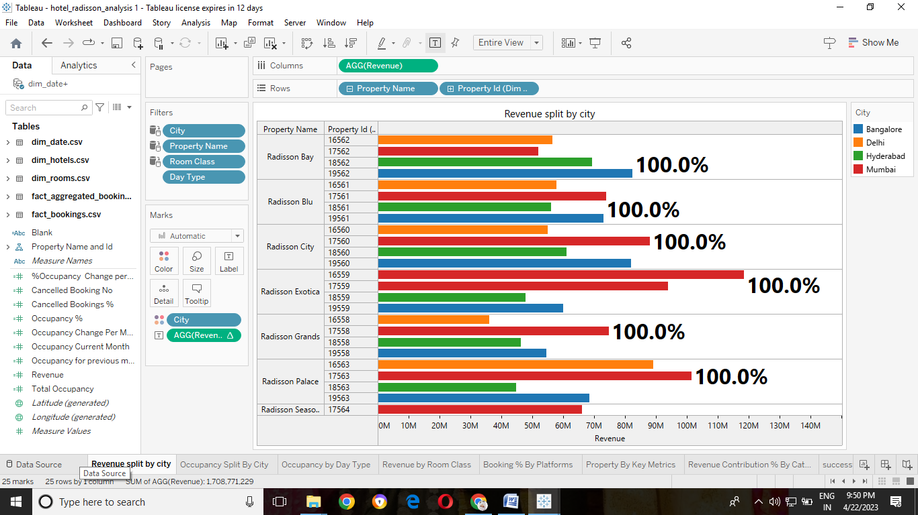

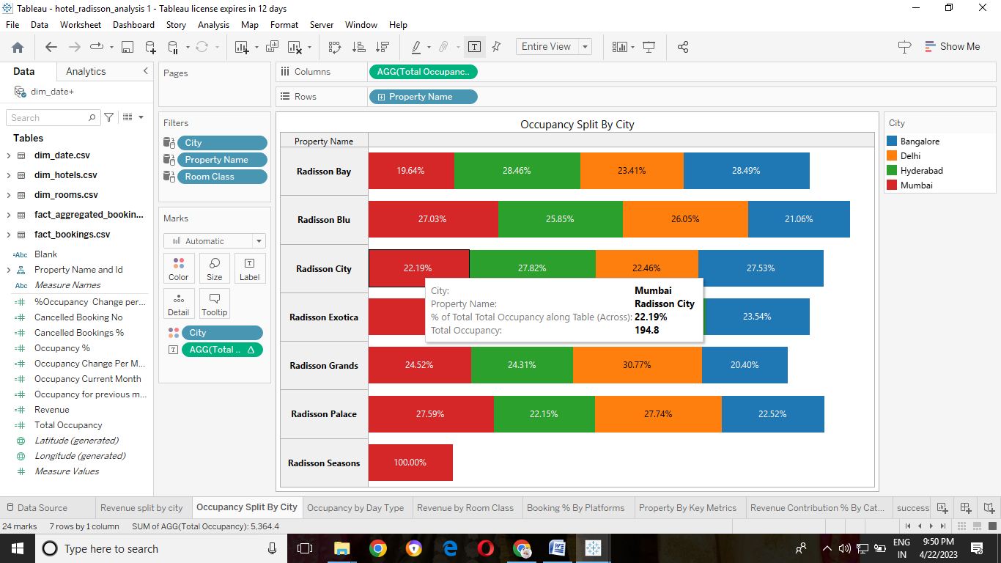

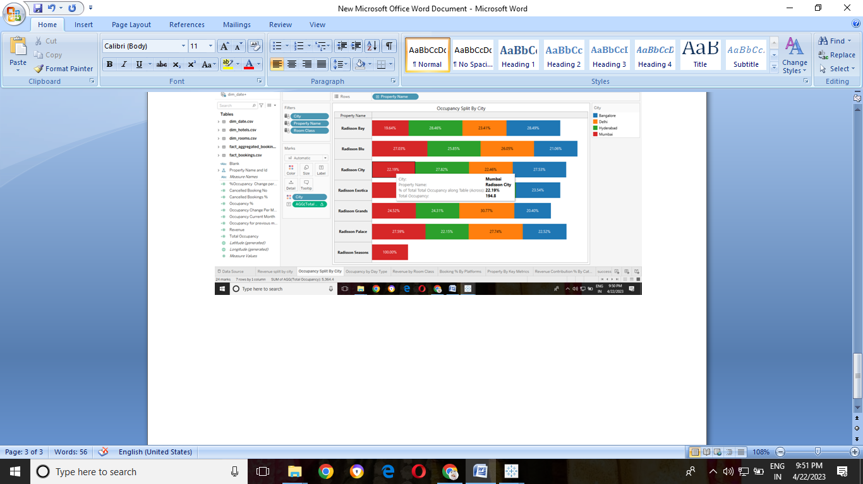

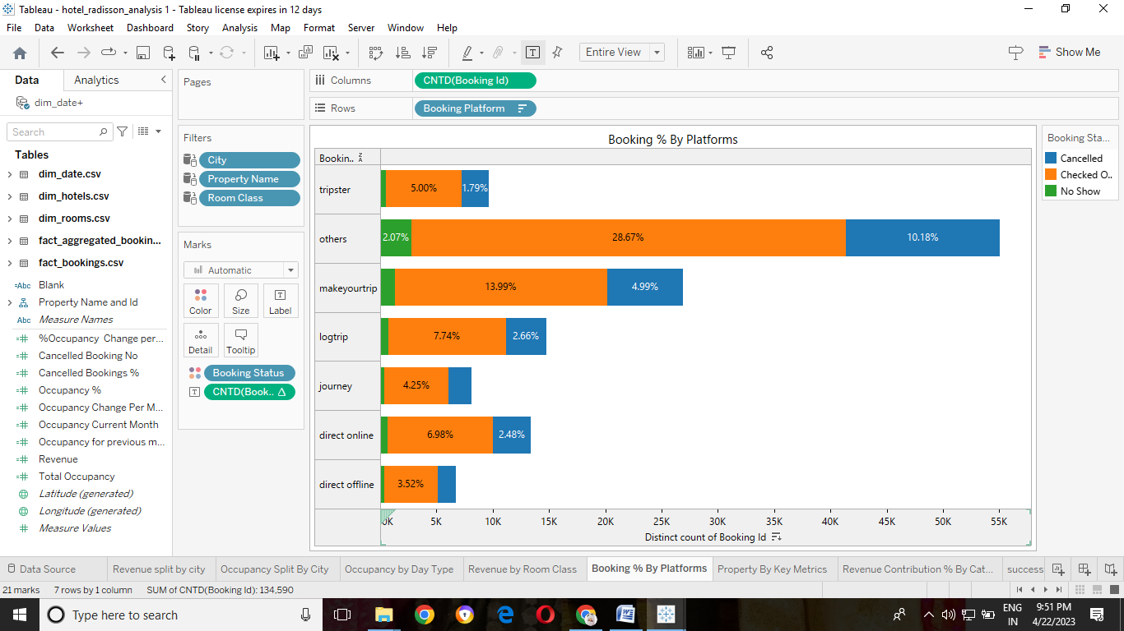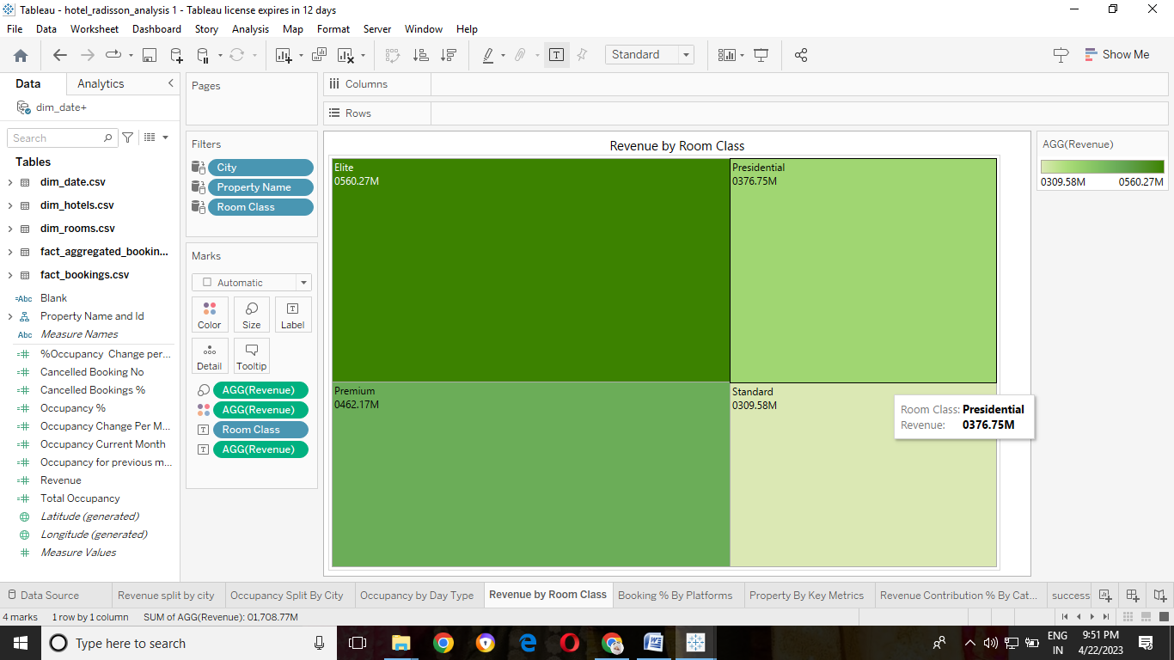

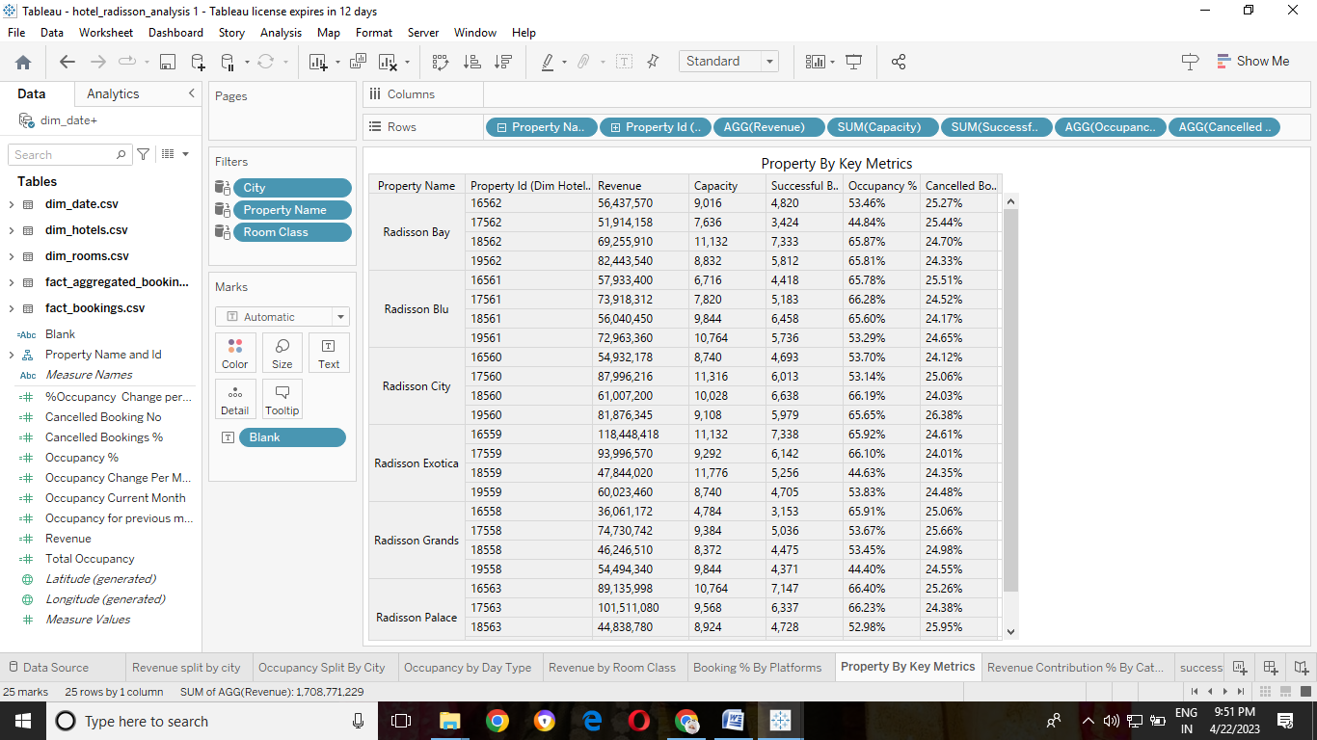

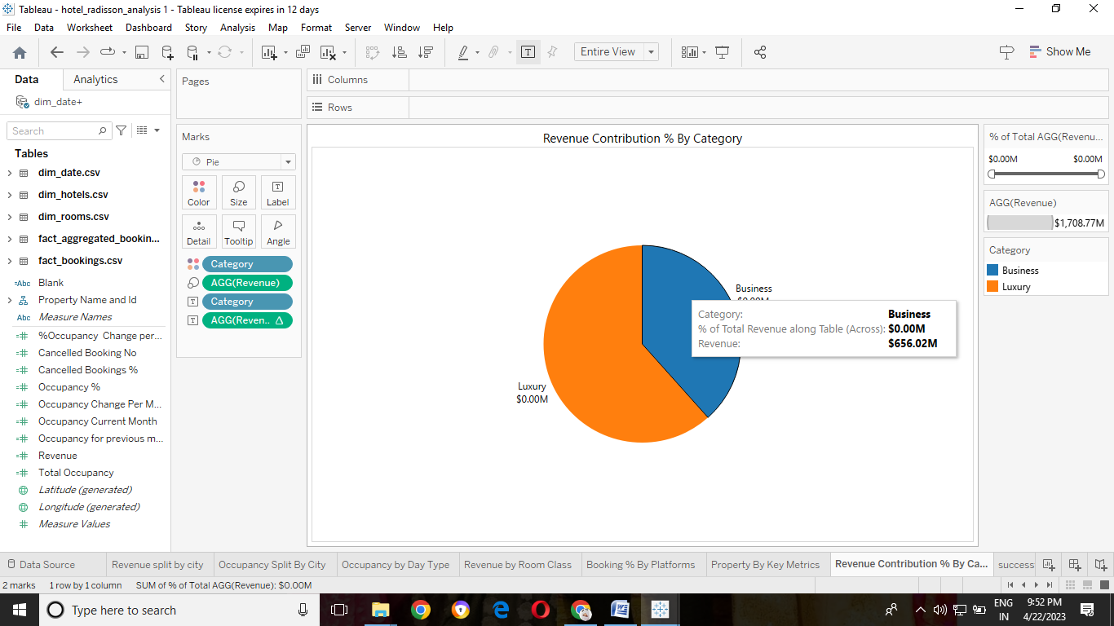

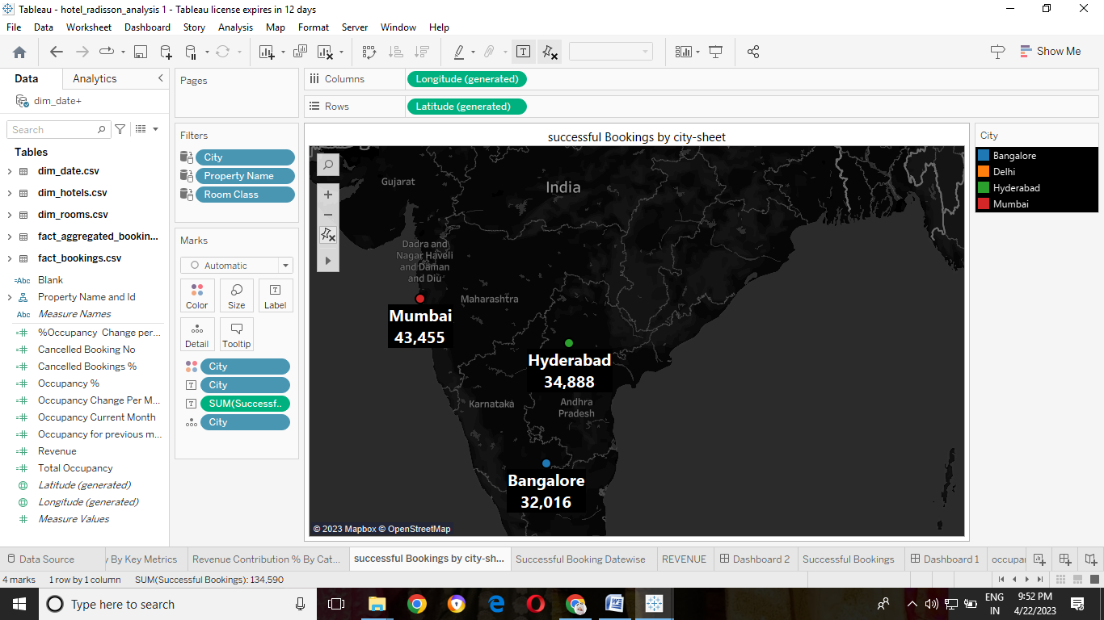

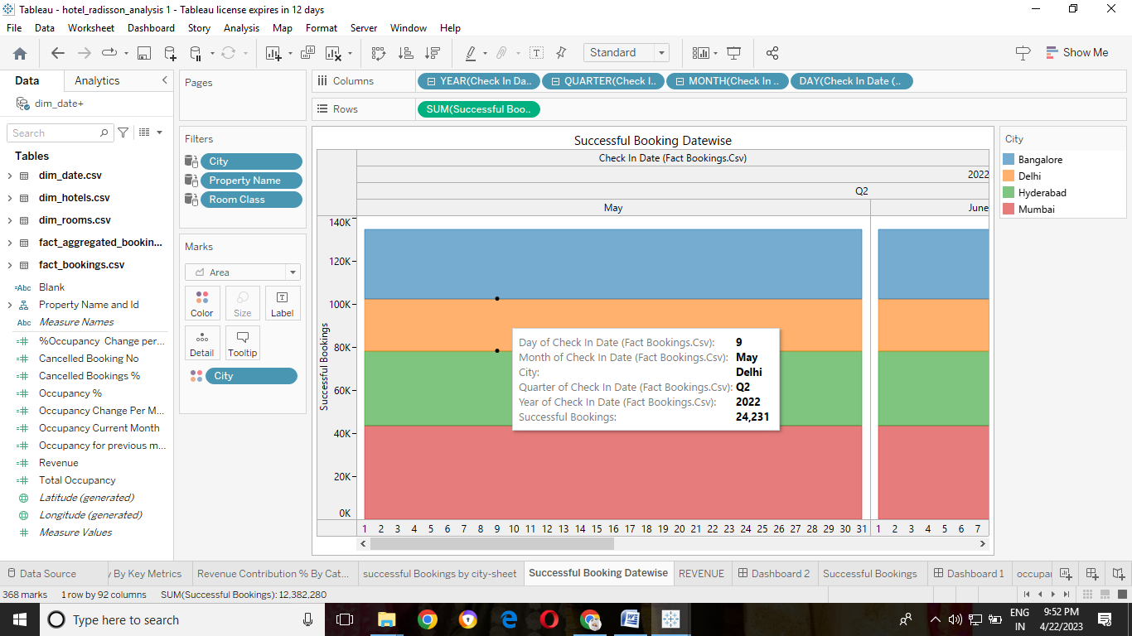

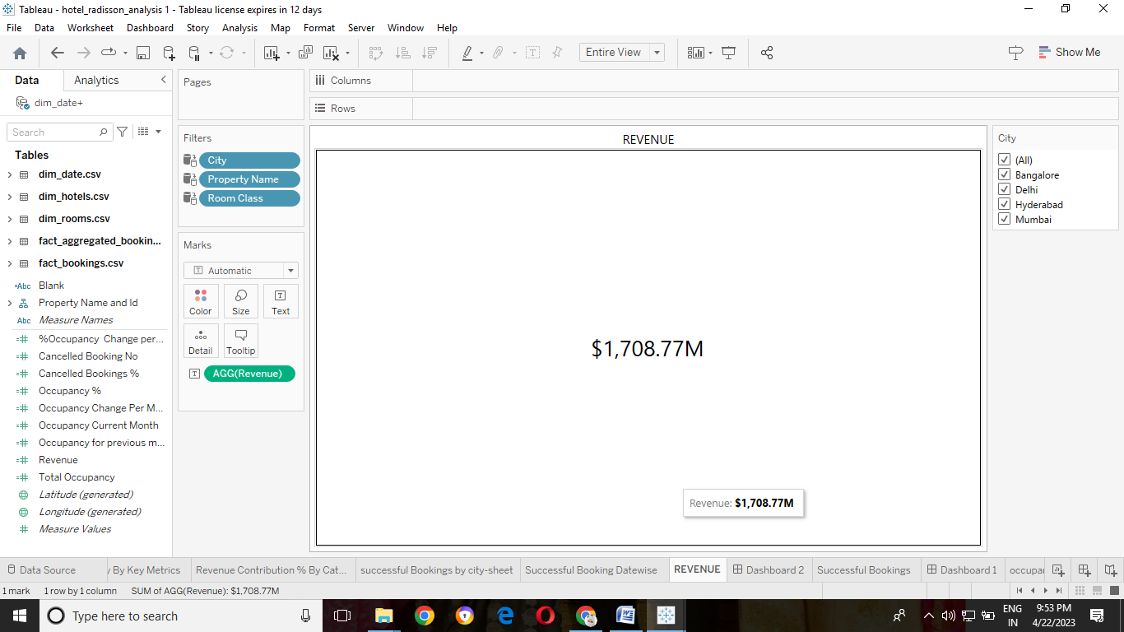

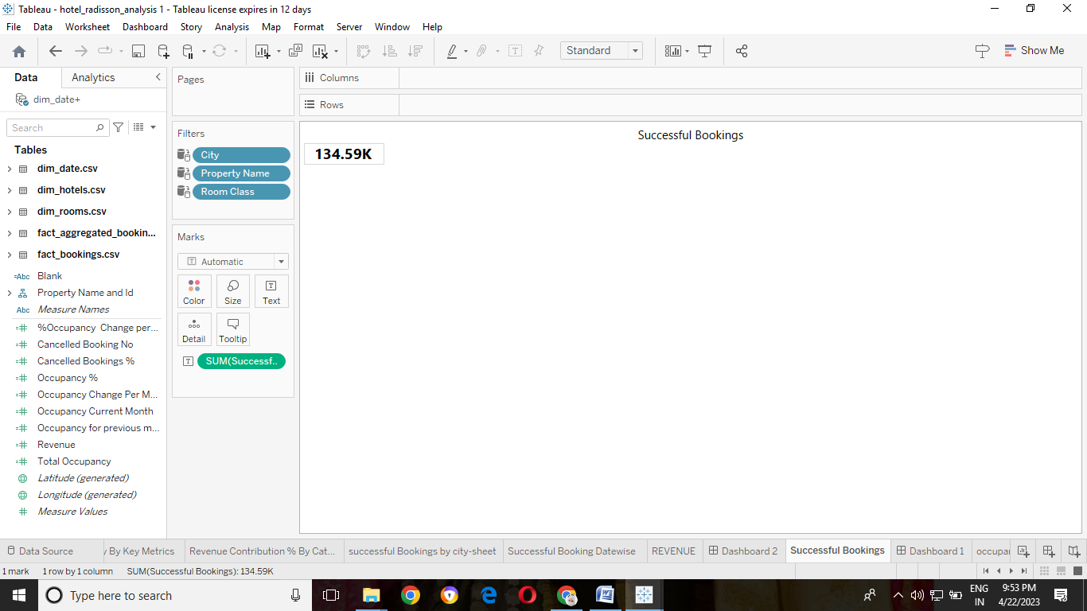

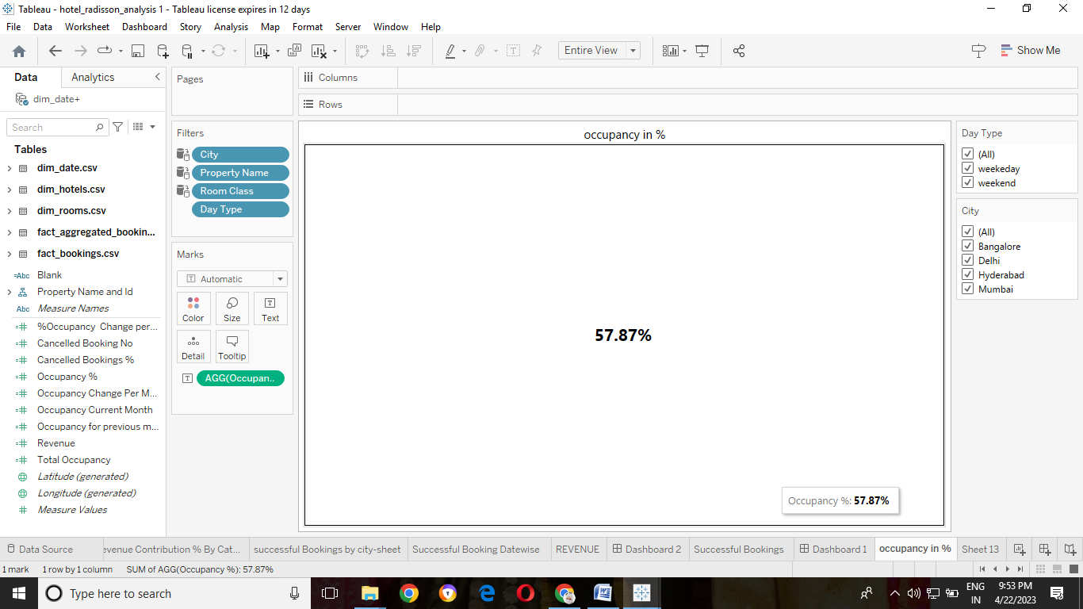

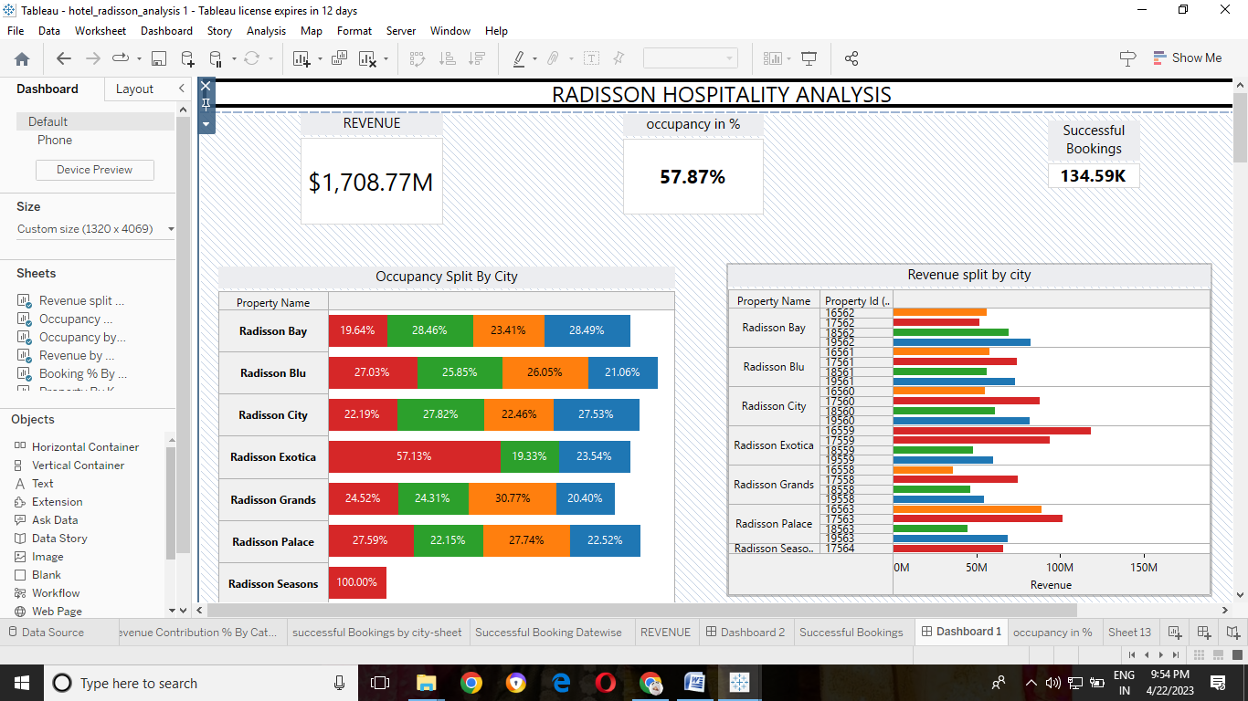

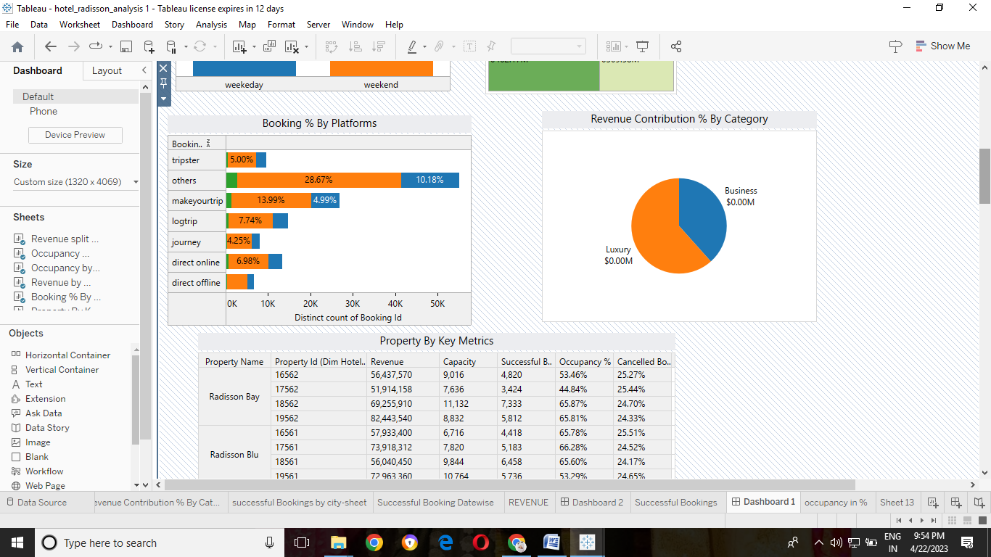

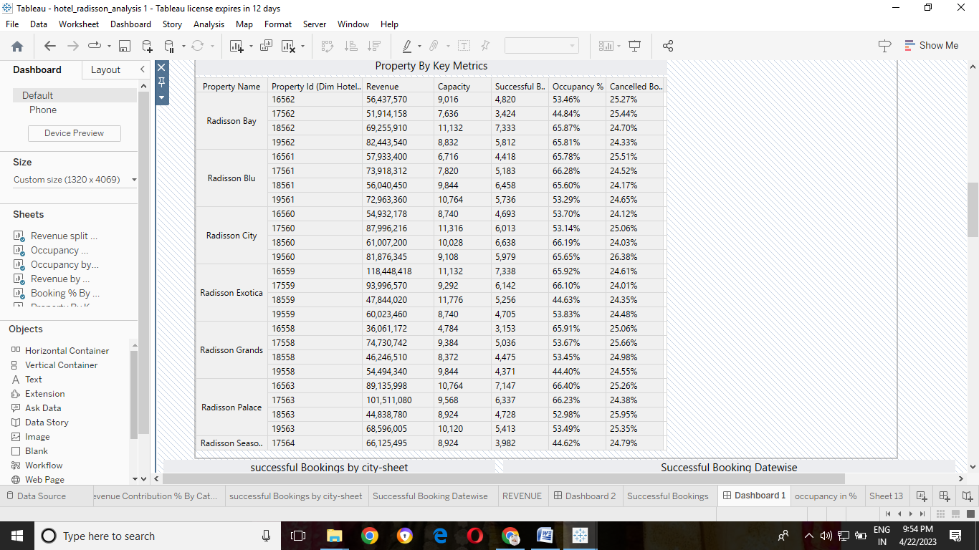

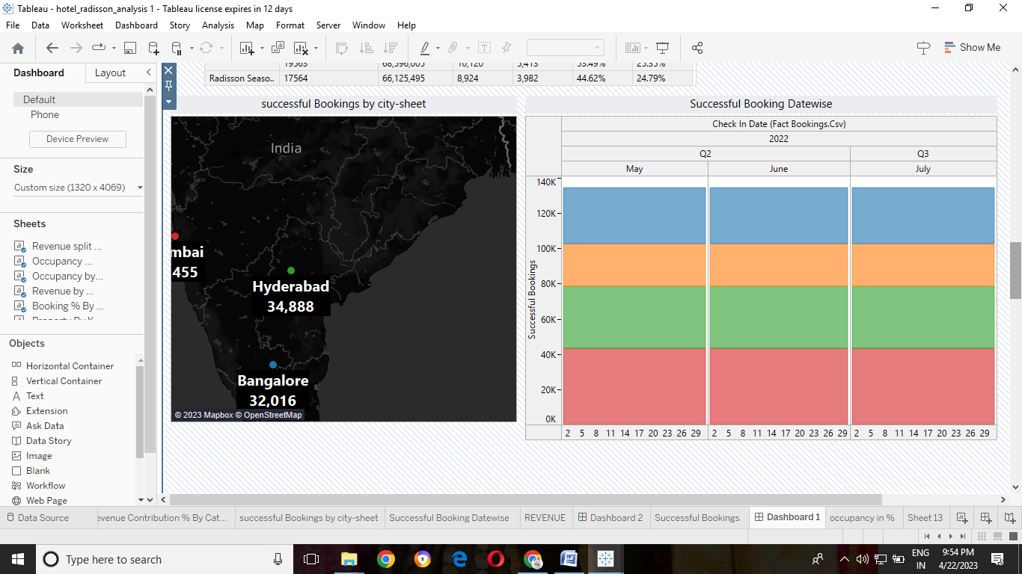

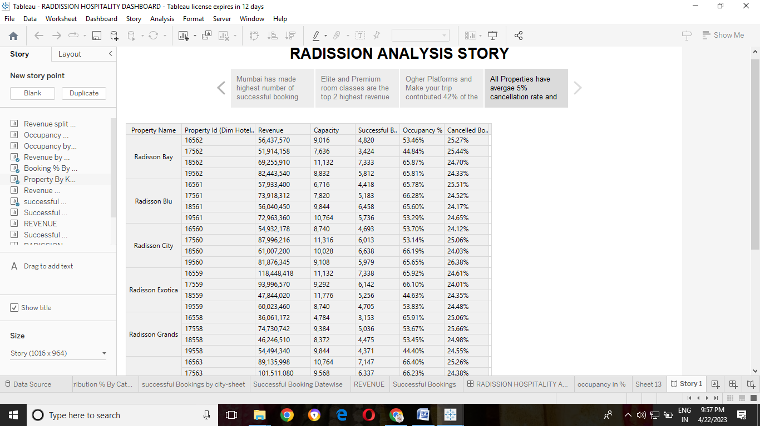

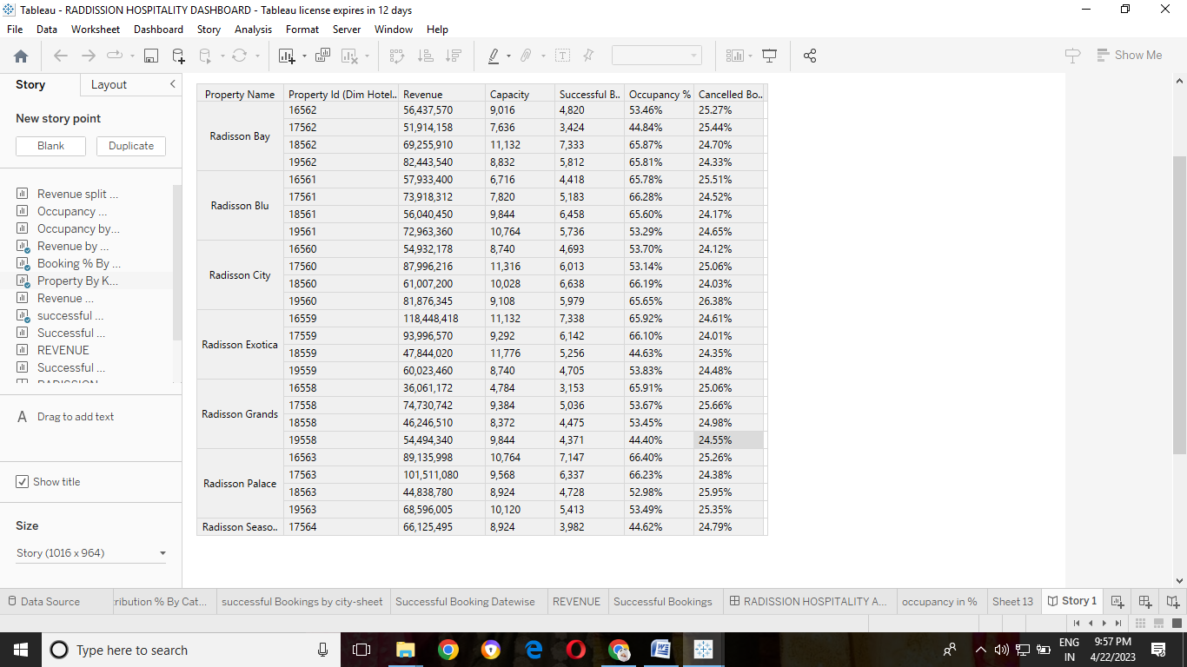

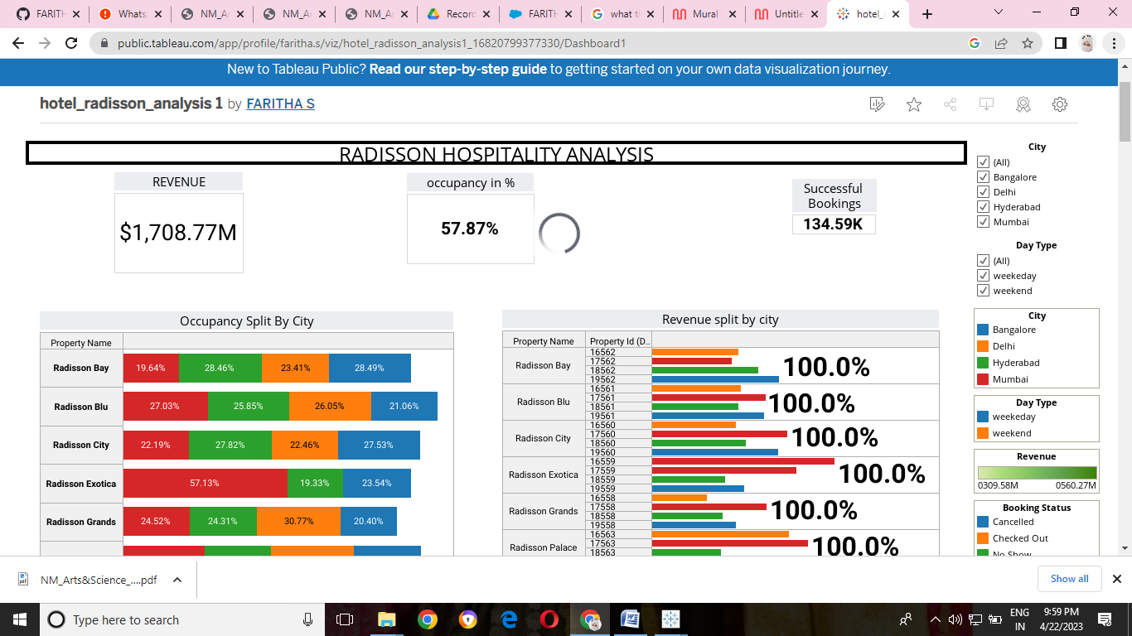

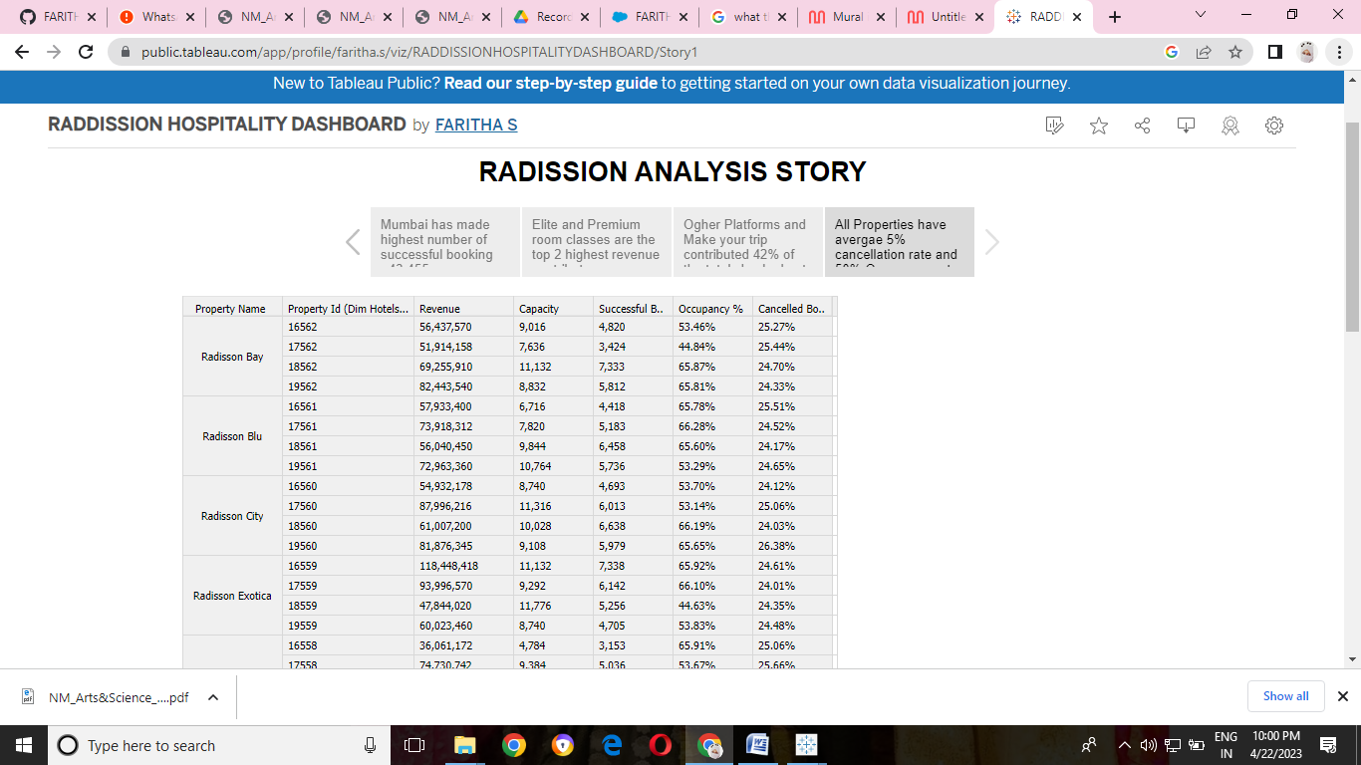

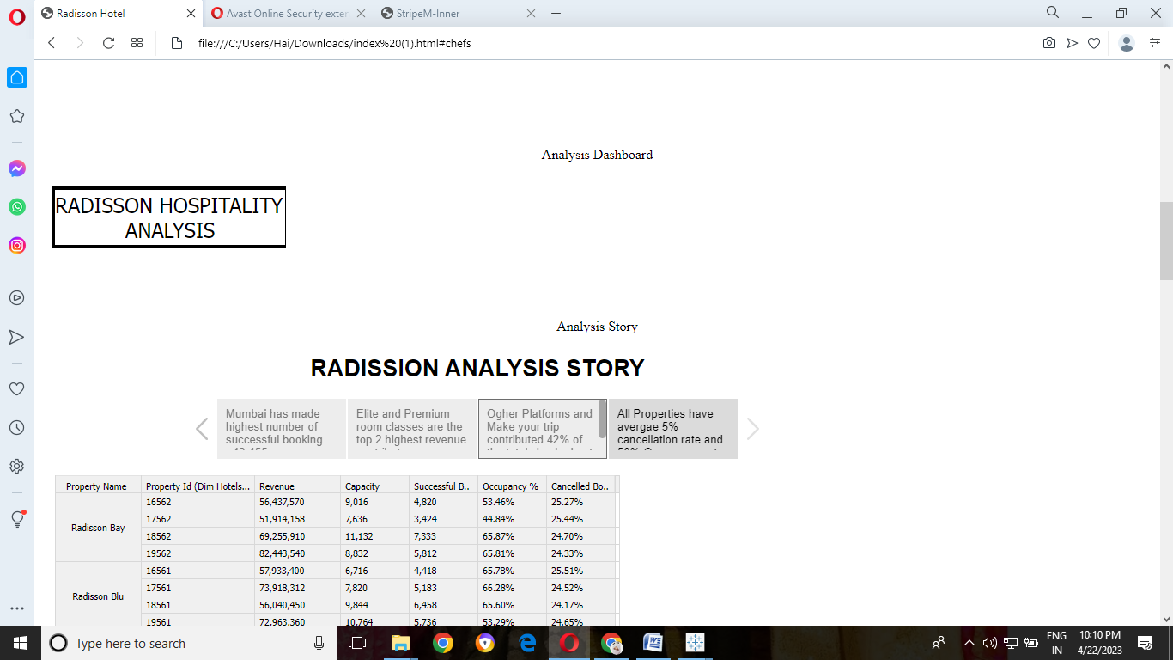

### ADVANTAGES & DISADVANTAGES:

|  |  |
| --- | --- |
| **Advantages** | **Disadvantages** |
| Extensive customer resources | Need manual effort |
| Excellent mobile support | Not a comprehensive solution |
| Easy to upgrade | No version control |
| Low cost | Requires SQL knowledge |
|  |  |

### APPLICATIONS:

The major work of Tableau software is to connect and extract the data stored in various places. It can pull data from any platform. Tableau can extract data from any database, be it Excel, PDF, Oracle, or even Amazon Web Services.

### CONCLUSION:

**data analytics** refers to collecting, processing, cleaning, and analyzing large datasets to help organizations operationalize their big data

### FUTURE SCOPE:

It is just a tool used in **business analytics and intelligence**. Tableau is a good to have knowledge, but building a career out of tableau is never advisable.

### APPENDIX:

